Module Five Major Grade

1. Sales by region
2. Analyze sales data by state to determine where the company has the largest customer base.

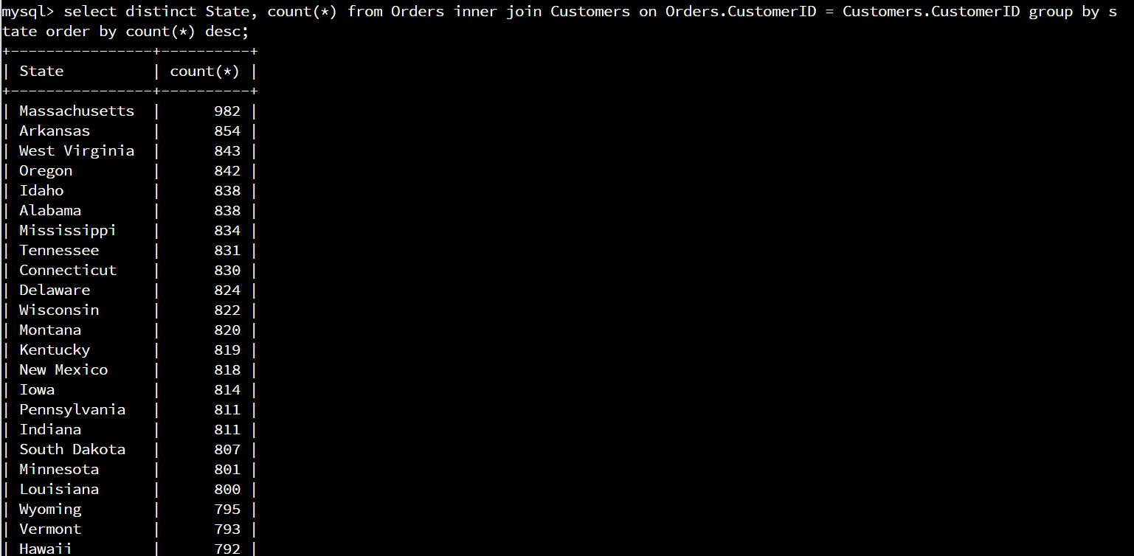

Command: SELECT DISTINCT State, COUNT(*) FROM Orders INNER JOIN Customers ON Orders.CustomersID = Customers.CustomersID GROUP BY State ORDER BY COUNT(*) DESC;

The largest customer base is in Massachusetts.

1. Analyze the data to determine the top three products sold in the United States.

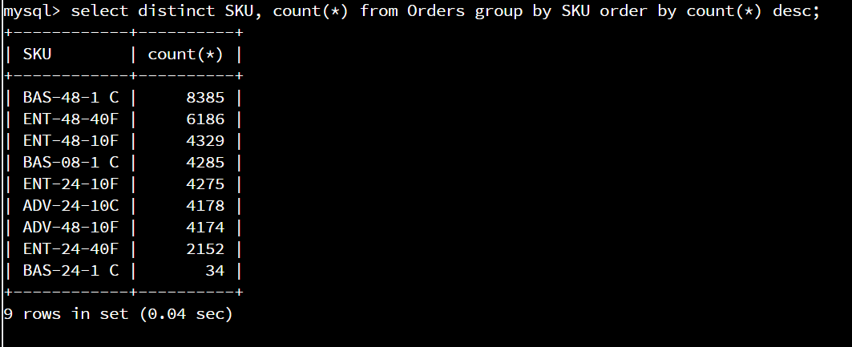

Command: SELECT DISTINCT SKU, COUNT(*) FROM Orders GROUP BY SKU ORDER BY COUNT(*) DESC;

BAS-48-1 C, ENT-48-40F, and ENT-48-10F are the 3 highest selling products in the United States.

1. Analyze the data to determine the top three products sold in the southeastern region of the United States.  
   * Southeastern states to include in your analysis: Virginia, North Carolina, South Carolina, and Georgia

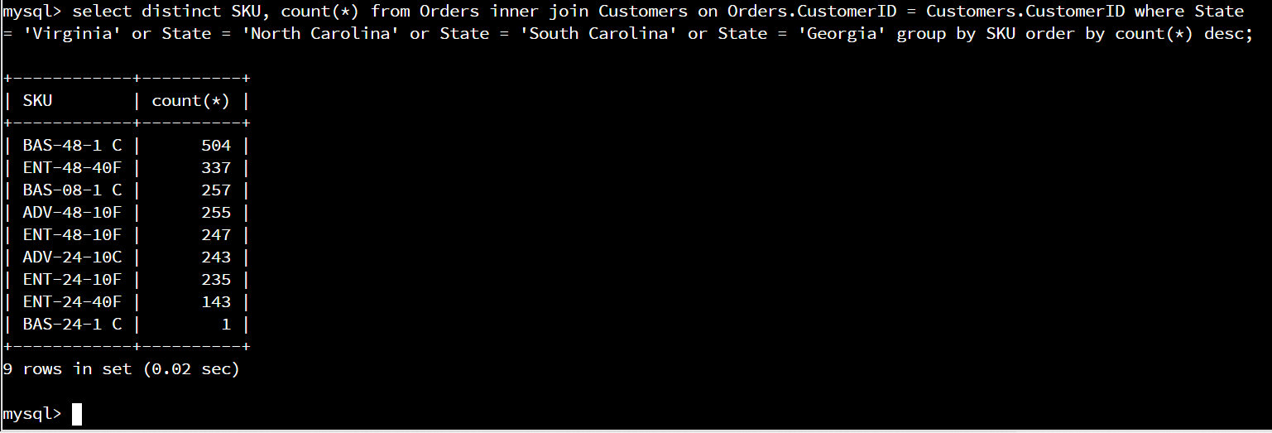

Command: SELECT DISTINCT SKU, COUNT(*) FROM Orders INNER JOIN Customers ON Orders.CustomerID = Customers.CustomerID WHERE State = ‘Virginia’ or State = ‘North Carolina’ or State = ‘South Carolina’ or State = ‘Georgia’ GROUP BY SKU ORDER BY COUNT(*) DESC;

The top three products sold in the southeastern region are BAS-48-1 C, ENT-48-40F, and BAS-08-1 C.

1. Returns by region:
2. Analyze the data to determine the top three products returned in the United States.

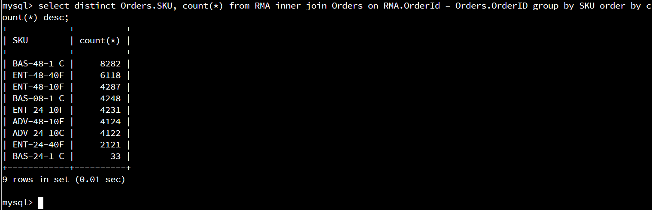

Command: SELECT DISTINCT Orders.SKU, COUNT(*) FROM RMA INNER JOIN Orders ON RMA.OrderID = Orders.OrderID GROUP BY SKU ORDER BY COUNT(*) DESC;

The top three products returned in the United States are BAS-48-1 C, ENT-48-40F, and ENT-48-10F.

1. Analyze the data to determine the top three products returned in the northwestern region of the United States.  
   * Northwestern states to include in your analysis: Washington, Oregon, Idaho, and Montana

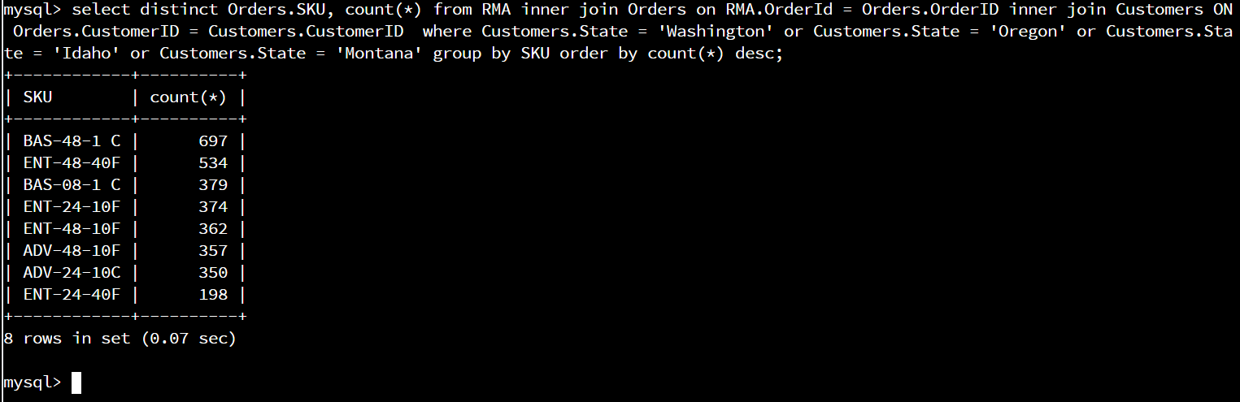

Command: SELECT DISTINCT Orders.SKU, COUNT(*) FROM RMA INNER JOIN Orders ON RMA.OrderID = Orders.OrderID INNER JOIN Customers ON Orders.CustomerID = Customers.CustomerID where Customers.State = ‘Washington’ or Customers.State = ‘Oregon’ or Customers.State = ‘Idaho’ or Customers.State = ‘Montana’ GROUP BY SKU ORDER BY COUNT(*) DESC;

The top three returns in the northwest are BAS-48-1 C, ENT-48-40F, and BAS-08-1 C.

**Write a report** to the Quantigration product manager that explains your findings in a way nontechnical stakeholders can digest and use.

* 1. This report should include an effective summary of the analysis of the captured data.   
     1. The highest amount of product sold in the United States is in Massachusetts. BAS-48-1 C, ENT-48-40F, and ENT-48-10F are the 3 highest selling products in the United States. The top three products sold in the southeastern region are BAS-48-1 C, ENT-48-40F, and BAS-08-1 C, which is close to national sales numbers, with number 1 and 2 being the same and only varying starting at number 3.
     2. The top three products returned in the United States are BAS-48-1 C, ENT-48-40F, and ENT-48-10F. The top three returns in the northwest are BAS-48-1 C, ENT-48-40F, and BAS-08-1 C, which is close to national return numbers, with number 1 and 2 being the same and only varying starting at number 3. I feel that we have incomlete information on actual sales though unless every single product sold is also returned.